The role of ERP in I4.0

Hoa Truong

University of South Australia

Course Enterprise Systems

Table of Contents

Executive summary 2

Introduction 2

Industry 4.0 3

History of Industry 4.0 3

Vision of Industry 4.0 5

Enterprise Resource Planning 6

Introduction and history of ERP 6

Challenges 6

Future of ERP 7

SAP 7

History of SAP 7

Examples of SAP adoption 8

ERP and Industry 4.0 9

ERP in relation to Industry 4.0 9

Implementation of ERP with regard to Industry 4.0 9

Criteria and challenges 11

Conclusion 12

References 12

# Executive summary

The latest Industrial Revolution is the defining moment of technology and automation into manufacturing. In this era, everything is about being more intelligent and reducing manual forces. Moreover, the role of data processing is significant in enterprises during this time. Smarter management of information means time-reduction on other tasks, give full insight to personnel and make data comprehensive, predictive, profitable. This adds up to a company’s competitive edges not only against their competitors, but also toward the better working environment in the future.

It is true that the core areas of Industry 4.0 lie in (but not limited to) manufacturing sectors, other industries and fields have also followed governments instruction on pursuing technical advantages and better connection. It is an ecosystem with national/international policies, guidelines, favours; internal knowledge and technology transformation; exchange of information between stakeholders and ERP expert's assistance that together make Industry 4.0 a universal endeavor.

ERP plays an undeniable role in Industry 4.0 from the way it governs information, manages business relationships, communicates with smart technologies within a firm working environment... ERP and Industry 4.0 makes a charming codependent and feasible cohabitation.

# Introduction

Innovative companies can benefit from technology advancements to extend their comprehension of data and their better their business activities, relationship management, which closes the knowledge gap between internal employees. Industry 4.0 is an evolutional era where companies strive to achieve structural execution of their business functions. Investigations based on both academic and industrial case studies makes guidance and marketing materials appropriate and approachable to companies that wish to close that gap.

With the fast growth and the presence of ERP occupying the market in different products internationally, there are potentials for companies to upgrade their existing ERP/ CRM systems and improve their security systems. Implementation of ERP comes with a various gateway for enterprises to manage their data flow and analytics, which sometimes involve extra skillset from using ERP system(s). The implementation of ERP should be done with a roadmap created by IT and organisational experts, and with a meticulous scope design to ensure not only the existing systems in the adopt institution are compatible but future networks are also possible to be a part of the enterprises ecosystem.

In this report, the concept of the Fourth Industrial revolution is mentioned along with its supporting quintessential model. The role of ERP in this matter is a representative of technological cooperation to manage factories and its involved systems. SAP as an ERP product has been progressively contributed to IT transformation of enterprises in Industry 4.0. It is possible that with the help of ERP implementation, companies can achieve their ambition in pioneering in the market, and change their industrial region in synchronisation with national/international definition of Industry 4.0.

# Industry 4.0

## History of Industry 4.0

Industry 4.0, despite its far-reaching presence in the history of civilization, still has its ambiguous side when brought into different context of many industries. Overall, it concludes worldwide yearning for smart engineering that frees us from hard labour and poor production planning. It is concluded that Industry 4.0 involves Information Technology point of view that impacts/ bring evolution to systems in factories. Moreover, this development/transformation also contain flexible organisational suggestions (Lasi, 2014).

Comparing to other version of industrial revolution since the 18th century, Industry 4.0 surpasses its earlier time with indication of intelligent production (Oztemel, 2020).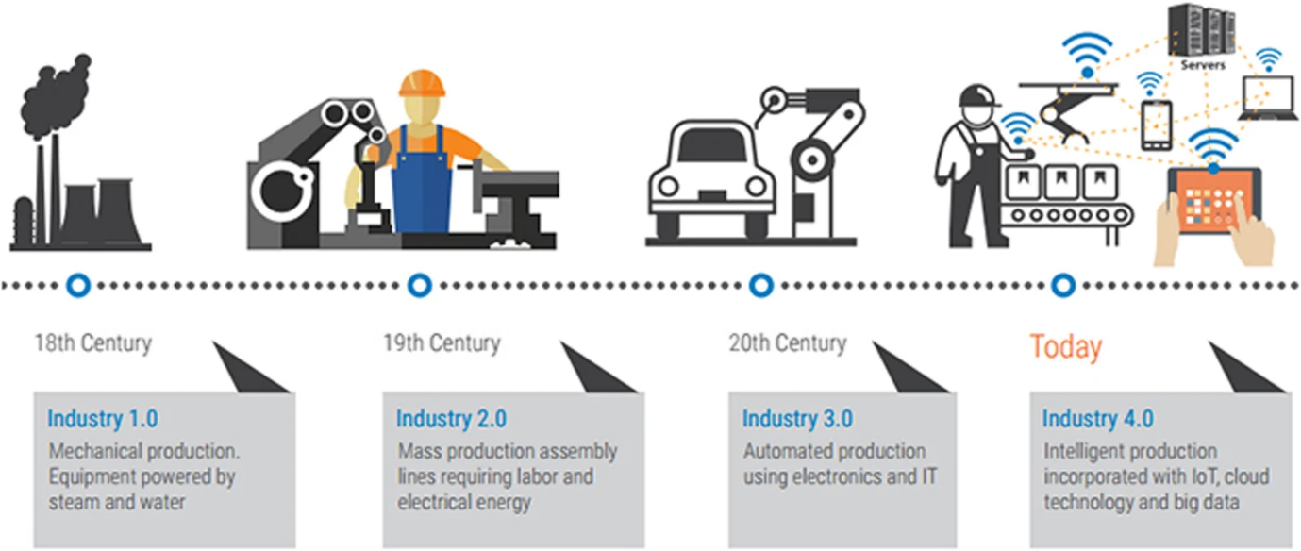

Particularly, manufacturing in industry 4.0 is the contribution of smart manufacturing, which comes down to the concept of IMS (Intelligent manufacturing system); manufacturing powered by IoT, and cloud- based manufacturing. IMS is consists of process and supporting devices that can collect information, analyse it and propose smart decisions based on analysed data, which associates with the introduction of AI. IoT- powered manufacturing deals with real-time collection of information with the establishment of wireless and other internet-based solutions. And cloud computing, cloud services is the premise of cloud manufacturing. Zhong et.al developed a framework for intelligent manufacturing consisting of brilliant design, machine, monitoring, control and scheduling; the details of this framework and how it communicates with supporting techniques, technologies are described in the following figure. Smart design is achieved via intelligent and labourless design software. Smart machine introduces the assistance of robot and tiny objects that can exchange information with each other, and sense in real-time matter. Monitoring in an intelligent way refers to maintenance and operating tasks that are optimised and aided by many kinds of sensors. Control aims at using cloud computing to successfully handle smart devices. In order to optimise smart scheduling, the techniques to be used must be the one that are based on data and involves progressive decision architecture.

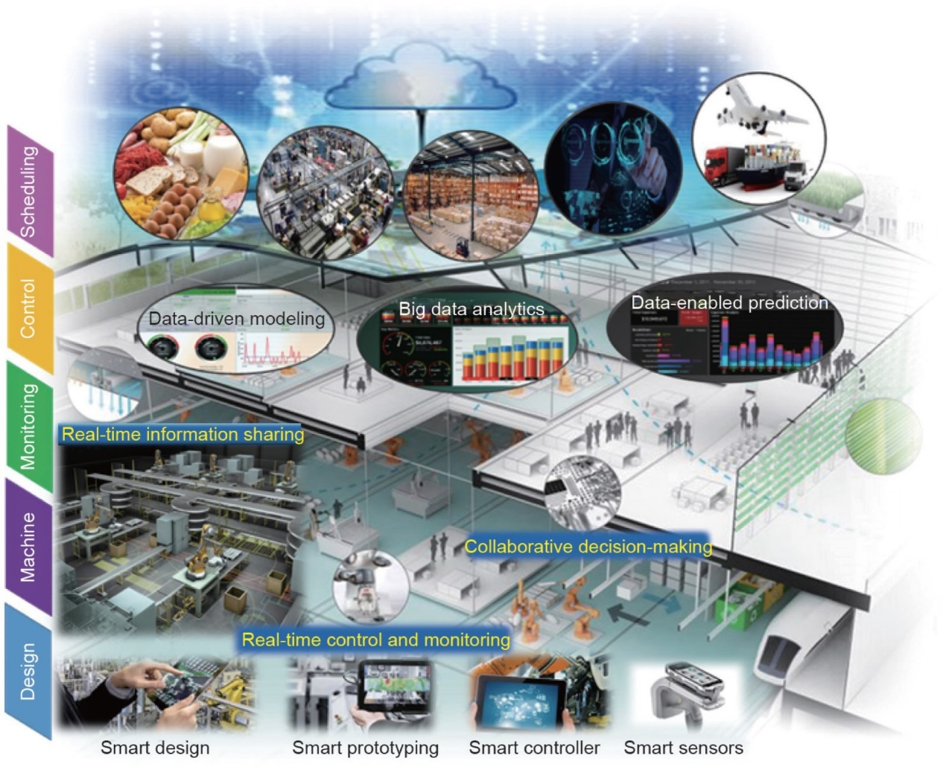

(Newman, 2017)

## Vision of Industry 4.0

Companies of all sizes while pursuing their parts in Industry 4.0, not just in manufacturing, production and supply chain management, Industry 4.0 is also mentioned in energy, education, city planning, etc..... International companies and organisations consider adopting software and systems after being persuaded by its cost-effective, centralised, professional traits. For example, Adenuga et al. Figured that by adopting energy efficiency system with the help of sensors, data collection and data analytic tools, the outcome is more economic, timesaving and more efficient that before adoption (Adenuga, 2019).

Sometimes, with effort to be a pioneer in Industry 4.0 comes with other intangible obligations, the Textile industry is a vivid example. Implementing software and smart devices are not only to solve the cost-effectiveness problem, but also to become more environmental- friendly, at the same time to comply with expected emission standards (Tsai, 2018).

Being ambitious with industry 4.0 is not within one nation. Many countries are investing a heap of money for this automation time to come true. In many developing countries, this has been presented to governmental organizations and local authorities. In Vietnam, the word Industry 4.0 includes more than just technology and automation, it has been confirmed by PM of the country that there will be policies and regulations to favour and encourages businesses to implement necessary technologies in pursuit of Industry 4.0 (Huong, 2019).

# Enterprise Resource Planning

## Introduction and history of ERP

It is impossible to refer to an ERP system and forget its complex structure of information technology. Since it is the harmony of IT and business work together and computing devices are becoming cheaper, it is possible for even SMEs to consider ERP. In the early days, first generation ERP systems are compatible for large mainframe computers. However, with the development of technologies, the beginning of server technology and systems deal with relational database (RDBMS) makes the implementation of ERP more convenient (Gupta, 2000).

Implementation of ERP is not without its flaws. There have been numerous records showing problems when establishing ERP, also the installation of ERP faces high risks, time-consuming to install and it might overrun. Organisations once implementing ERP they also are aware of changes in Human Resource as of recruit experts for the systems (Trimi, 2005).

It is indisputable that ERP provides a reasonable and structured backbone to an entity. However, sometimes the adoption of ERP into grand, sophisticated projects leaks off many restraints, in a way that its platform only solves problems and not to focus on the problem itself. Having a solution-oriented approach lacks the flexibility and centralisation that in such projects those traits are not enough.

## Challenges

For example, on the bright side ERP helps with administration and relationship management (customer-supplier) since it is famous with customer order task, invoice and inventory management. However, in large and decentralised entities, ERP core value sends conflicting traits:

* Organisational hierarchy: the hierarchy process within ERP function might be an obstacle for unexpected business actors such as business partners and subcontractors, this might affect the decision-making process.
* Because of the sophisticated logistics flows and its related partners, it is a pitfall when seeing ERP’ applications while they are made of processes.
* Centralisation makes it hard to manage data while still have to consider company policies and standards; hence, integrating with another enterprise information systems is not fully done, also the exchange and sharing of information in the distributed network is limited (Kovács, 2003).

## Future of ERP

In the future, the implementation of ERP means enterprises are looking for intelligent technology, the kind that can make business suggestions based on data mining and smart device. Also, the future of ERP will boost simulation, hence the following sections can perform better: finance department (accounting); planning activities that are related to supply management. Large acquisitions have been recorded within the industry to create better CRM solutions for enterprises (Oracle and Siebel- creator of CRM applications...)(Robert Jacobs, 2007).

# SAP

## History of SAP

The history of SAP dates back to the mid-1970s when major software companies are the pioneers in the ERP market. Mannheim (Germany) is the city that hosted five engineers who committed to starting SAP - (known as Systemanalyse und Programmentwicklung) in 1972. Their company aims at creating a standard software for the market and providing solutions for integrated businesses (Robert Jacobs, 2007).

Since then, SAP has many big names listed as their customers and partners, with the mission to bring solutions to enterprises in all over the world. SAP and its ecosystem can communicate with many other applications, as a result, can execute almost all (and sometime all of the) business operational quests. The products might come as on-premises software, cloud-based or private. Conventional on-premises software of SAP might have the systems listed as below: SAP ECC (ERP Central component, executes main operational business functions), APO (Advanced Planning and Optimisation- executes planning related functions, control censors), TM (Transportation management- routes planning and control), EWM (Extended warehouse management), BI and CRM (Lech, 2019).

## Examples of SAP adoption

As an ERP company and have a prestige role in Industry 4.0, SAP announces its mission as not only focusing on intelligent manufacturing but also boost connection with all end users within client organisations (website, 2021).

With a clear mission and innovative products, the adoption of SAP has now been worldwide and extensively in the developing worlds. Previously, there are several investigations on SAP customers experience from various countries both for academic purpose and project management, the common thing of those investigations is that client from developing countries have less experience when engaging with SAP. Consequently, the involved stakeholders see their roles in relation to clients and suppliers, leads to vagueness in contract. This lifts the costs for transaction for both actors. However, in the developed countries things are different, contracts are carefully communicated and the scopes for implementation projects is clear and uniformed. Therefore, the pressure toward client- suppliers relationship is less burdensome, and less customisation is detected (Lech, 2019).

The lack of ERP experience is shown in another academic case, ERP systems are less likely to be introduced into universities curriculums due to the shortage of resources, as SAP is not an exception (Blount, 2016).

It is possible that despite its marvelous features to get closer to Industry 4.0, there are still limitations for organisations to implement suitable ERP systems. Similar products as competitors to SAP (Microsoft ERP, Oracle ERP, Open-source ERP systems...) face the similar fate. However, as many countries and regions favour technology advances, it is only the matter of time before Industry 4.0 changes business activities from the core of internal IT adoption.

# ERP and Industry 4.0

## ERP in relation to Industry 4.0

Coming back to core definition of Industry 4.0 and its supporting elements. Deloitte simplified what has made Industry 4.0 enticing is the involvement of smart technology, its interconnection and Big data:

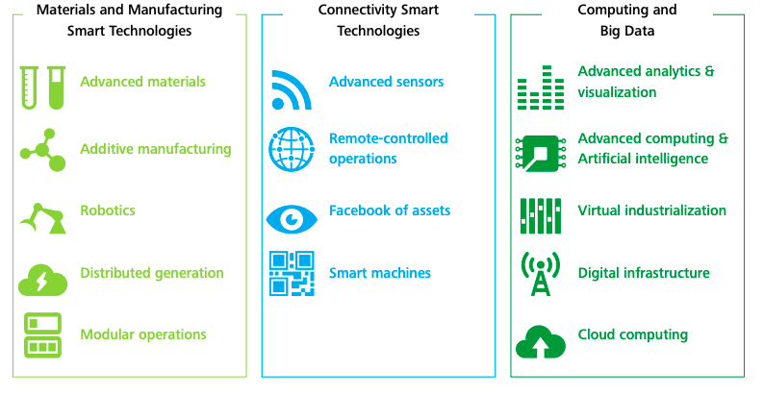

(Deloitte, 2015)

In many aspects, ERP helps in material management in a smart way, connects with other intelligent existing systems and Big data involvement promotes data management for ERP (in the future).

Basically, the target of ERP matches Industry 4.0 at the word “automation”. Bruce Bond, who was a specialist (Research Director from Gartner) at the time as he quoted that ERP concentration has now extend to enabling automatic salesforce, better in scheduling and planning, managing customer data and digital-based relationship (Siragher, 1999).

## Implementation of ERP with regard to Industry 4.0

Industry 4.0 is a shared effort of intelligent elements such as Cloud services, robots, Big Data, AR and IoT… and sometimes, those technologies are too expensive to adopt all together. For example, El Palmar plant takes advantages of System Integration, Industrial IoT, Cloud environment and Big Data. One of the issues that Industry 4.0 has to face is how to efficiently make use of all three elements: Human resources, energy, tangible matters (Alarcón, 2021).

Implementation of ERP in organisations facing financial difficulties does not mean that small enterprises stand no chance in Industry 4.0 with small budgets. KKKO, a manufacturer belongs to category SMEs is an example of how small entities can still be competitive in the digitalisation world. During a case study of KKKO, the company firstly adopt technology for production stages, then maintenance task, and QA in order to prioritise its chosen core business strategy. It is near impossible to have integration and- at the same time- information transparency as a shared effort from a network consisting of similar manufacturers; not to mention this needs to happen all over the chain of value, eliminate functional silos, and achieve automation. The change in the name of Industry 4.0 for this kind of manufacturers should be consistent with the organisation operation, while recognise the readiness of internal legal and technical issues. This case is a vivid example of gradual digitisation for certain functions and processes once in line with core strategies, abilities and policies, consequently, brings about advantages to be more competitive when speaking of Industry 4.0 (Ghobakhloo, 2019).

The role of ERP in Industry 4.0 is proven from even the smallest task it performs. At the time ERP systems was invented, Internet was born approximately. This adds up to a combination of factors that preconditioned electronic appliances and worldwide digitalisation of data. IMS (Integrated management system) found this advancement valuable in terms of managing and collecting information. Companies also found the continuous availability of technology when they want to build internal networks to collect and manage newsfeed for their ERP systems. Since then, even the smallest event within an organisation might be documented thanks to reasonable duty. After that collected data, then be replaced and communicated as a form of digital links among the firm’s employees. Technically, Customer Service personnel is aware of which payments belong to what orders, Logistics is aware of which inventory in demand and deliveries, Productions knows the general demand and provide relevant planning, Administration perceives financial problems and foreseeing sales and budget. Within this context, data collection and its later form is the result of complexed activities performed in accordance with Industry 4.0 (GUNIA, 2019).

## Criteria and challenges

Polivka & Dvorakova (2021) investigate suitable criteria to on decision of how to choose the right ERP systems. It is concluded that seven traits that make an ERP system compatible. First, the product must be made for horizontal system integration, which means it can communicate with other systems in adopt company. ERP system should be able to receive and send data from/to various software products:  SCM, MIS or PLM, MES, and SHS. Secondly, it needs to consider vertical system integration with regard to send/receive information with a company’s partners/ stakeholders. Thirdly, later implementations of other digital products should be compatible with ERP, in order for IT system to capture product lifecycle of adopted software and all involved stakeholders should be able to access that information when needed. Fourthly, the system architecture should be service oriented (SOA). With reference to Industry 4.0, the systems in this context should be manifold for potential individual usage independently, even out of the information system that has been inter-connected. The firth trait refers to cloud-based ERP, as with Cloud environment the system is able to exchange data freely, out of company infrastructures. The sixth trait, the system should make collection of information and data processing enabling, the data could come from various source (not excluding in the context of horizontal integration) and assess them with competent characteristics/filters. Finally, cybersecurity should be put foremost in prior to adopting any information system so that the organisation can fully be protected in terms of information security and availability with informed authorisations (Lilia Dvorakova, 2021).

It is indisputable that the jobs of ERP play an important role in Industry 4.0. in a way that companies need ERP/ CRM system for their pursue of advanced technology and automation. Likewise, it is difficult to imagine any firm that runs smoothly whilst not implementing ERP/CRM. It is desirable that companies can lift relevant barriers of past ERP products, the future of that would disclose following traits:

* Decision-making environment: the data collected and analysed should be able on sight of mobile and portable devices. This empowers ERP right as a real-time information provider.
* Big data: integral analytic functions should enable analysed results automatically with from a collection of massive and unstructured data from all sources in real-time manner.
* Performance in a virtual technical environment that helps companies connect with their stakeholders and partner simultaneously.
* Connection with social networks as an attempt to forward notices faster to end users (Stojkić, 2015).

# Conclusion

With the help of Enterprise Resource Planning vision and products, factories and companies are approaching an innovative scenario of Industry 4.0. ERP can cover most of business tasks within one business, help employers/employees make decision based on analysed data, and managing relationships among stakeholders. Everything is recorded and with reference per business assignments, people can track/extract and make use of information daily. However, the implementation of an ERP system needs to be done with consideration of the size of adopt institutions, in order to satisfy its business drivers and goals. Many adoptions of ERP products have been investigated for later examination of barriers and challenges, since ERP is not a perfect solution that matches ever project/institution characteristic. Adoption of ERP also comes with industrial expert advice, criteria checklist and later review for the best result in accordance to Industry 4.0 vision.

# References

ADENUGA, OLUKOREDE T., MPOFU, KHUMBULANI & BOITUMELO, RAMATSETSE INNOCENT 2019. Energy efficiency analysis modelling system for manufacturing in the context of industry 4.0. *Procedia CIRP,* 80**,** 735-740.

ALARCÓN, M., MARTÍNEZ-GARCÍA, FERNANDO MANUEL & GÓMEZ DE LEÓN HIJES, FÉLIX CESÁRAEO 2021. Energy and maintenance management systems in the context of industry 4.0. Implementation in a real case. *Renewable & Sustainable Energy Reviews,* 142**,** 110841.

BLOUNT, Y., ABEDIN, BABAK, VATANASAKDAKUL, SAVANID & ERFANI, SEYEDEZAHRA 2016. Integrating enterprise resource planning (SAP) in the accounting curriculum: a systematic literature review and case study. *Accounting Education (London, England,* 25**,** 185–202.

DELOITTE 2015. Industry 4.0

An Introduction.

GHOBAKHLOO, M. F., MASOOD 2019. Corporate survival in Industry 4.0 era: the enabling role of lean-digitized manufacturing. *Journal of Manufacturing Technology Management,* 30**,** 1–30.

GUNIA, B. C. G. 2019. DEVELOPMENT OF INTEGRATED MANAGEMENT INFORMATION SYSTEMS IN THE CONTEXT OF INDUSTRY 4.0. *Applied Computer Science (Lublin),* 15**,** 37–48.

GUPTA, A. 2000. Enterprise resource planning: the emerging organizational value systems. *Industrial Management + Data Systems,* 100**,** 114-118.

HUONG, M. 2019. PM Phuc at Davos: Industry 4.0 a policy revolution for Vietnam. *Vnexpress*.

KOVÁCS, G. L. P., PAOLO 2003. A planning and management infrastructure for large, complex, distributed projects—beyond ERP and SCM. *Computers in Industry,* 51**,** 163-183.

LASI, H., FETTKE, PETER, KEMPER, HANS-GEORG, FELD, THOMAS & HOFFMANN, MICHAEL 2014. Industry 4.0’. *Business & Information Systems Engineering,* 6**,** 239-242.

LECH, P. 2019. Enterprise system implementations in transition and developed economies: differences in project contracting and governance. *Information Technology for Development,* 25**,** 357–380.

LILIA DVORAKOVA, M. P. Selection of the ERP System with Regard to the Global 4th Industrial Revolution. EDP Sciences, 2021. SHS Web of Conferences, 04019.

NEWMAN, R. Y. Z. XUN X. EBERHARD K. STEPHEN T. 2017. Intelligent Manufacturing in the Context of Industry 4.0： A Review. *Engineering (Beijing, China),* 3**,** 616-630.

OZTEMEL, E. G., SAMET 2020. Literature review of Industry 4.0 and related technologies. *Journal of Intelligent Manufacturing,* 31**,** 127-182.

ROBERT JACOBS, F. T. W., F.C 2007. Enterprise resource planning (ERP)—A brief history. *Journal of Operations Management,* 25**,** 357–363.

SIRAGHER, N. 1999. Enterprise resource planning - the end of the line for the sales automation market and a major step towards sales process definition standards? *Supply Chain Management,* 4**,** 11–13.

STOJKIĆ, Ž.,  VEŽA, IVICA & BOŠNJAK, IGOR 2015. A concept of information system implementation (crmand erp) within industry 4.0. *Annals of DAAAM and Proceedings of the International DAAAM Symposium (Vienna),* 2015**,** 912–919.

TRIMI, S., LEE, SANG M, OLSON, DAVID L & ERICKSON, JOHN 2005. Alternative means to implement ERP. *Industrial Management + Data Systems,* 105**,** 184-192.

TSAI, W.-H. 2018. Green production planning and control for the textile industry by using mathematical programming and industry 4.0 techniques. *Energies (Basel),* 11**,** 2072.

WEBSITE, S. O. 2021. Industry 4.Now: Moving beyond the factory.